**How to Reproduce Project**

1. **Getting the tools** 
   1. **Visual Studio 2019**
      1. **Use this video link:** [**HERE**](https://visualstudio.microsoft.com/downloads/)
   2. **Unreal Engine 2.25**
      1. **Download Unreal Engine 2.25**

**Use this video link:** [**HERE**](https://drive.google.com/file/d/1lGweWoMuKPYzkLQIMiH3OQsRIBDJV5rh/view?usp=sharing)

* 1. **7Zip** 
     1. **to unzip the folder as its a huge folder and may crash the default Windows/Mac unzip tool**

**Use this download link:** [**HERE**](https://www.7-zip.org/download.html)

* 1. **Magic Leap**
     1. **Download and install the SDK**
  2. **Webcam 1080p**
  3. **Magic Leap Plugin for Unreal Engine**
     1. **Download Leap Plugin 3.6.0**

1. **Building Unreal Engine File from Source** 
   1. **Setting up Visual Studios for Unreal Engine** [**VIDEO**](https://www.youtube.com/watch?v=MRJUWC90aJM&ab_channel=Flopperam) 
      1. **Run the installer for Visual Studios**
      2. **Install Game development with C++ in workloads section of the installer**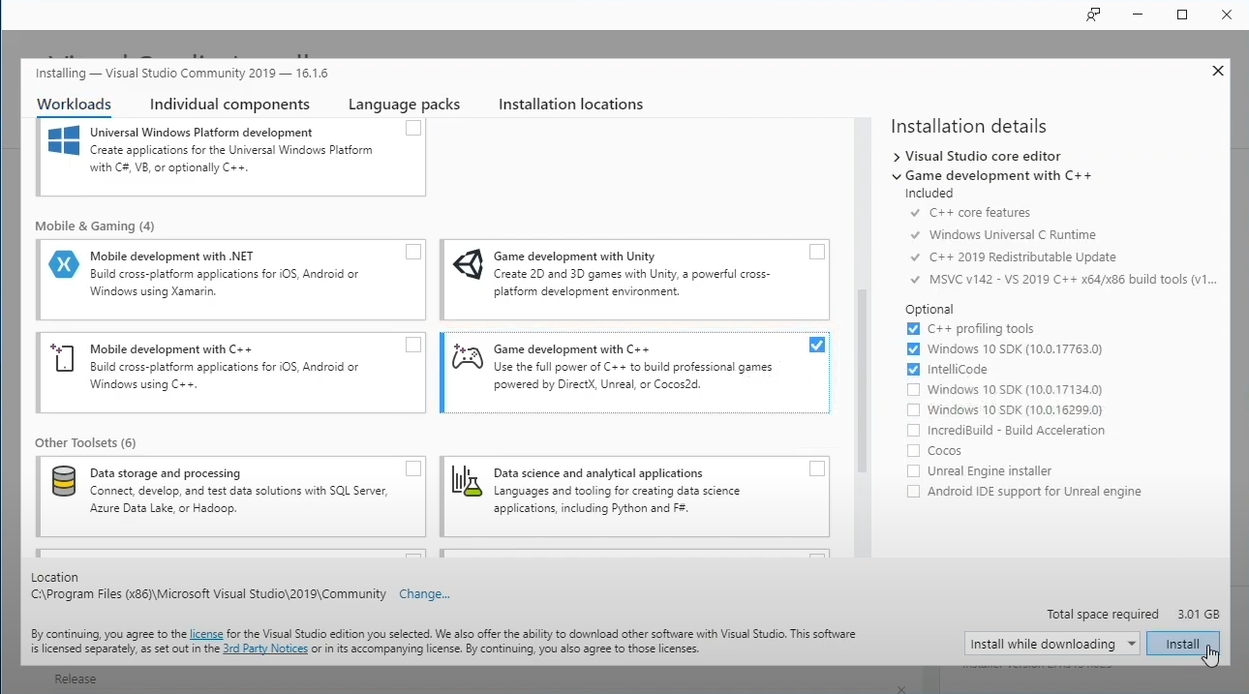
      3. **Install the Latest NET Framework SDK and the old Framework targeting pack**

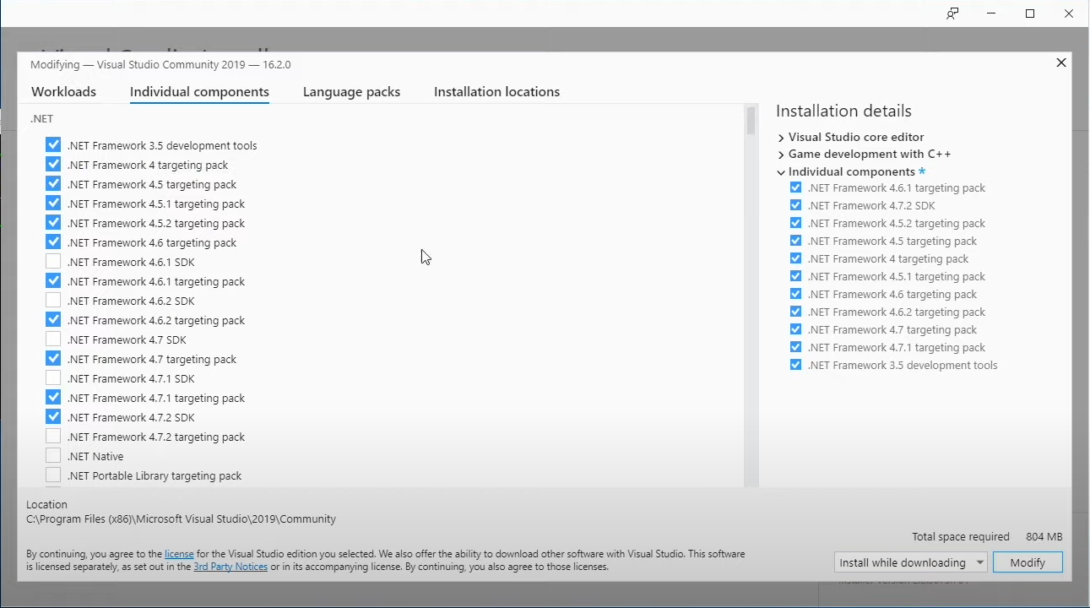

* 1. **Unzipping Unreal Game Engine**
     1. **Unzip the file using 7Zip to your desired place.**
  2. **Setting up Magic Leap Plugin for Unreal Engine** 
     1. **Download LeapUnreal-3.6.0.zip**
     2. **Unzip The LeapUnreal-3.6.0.zip folder**
     3. **Get the plugin**
     4. **Paste the plugin in this location in the Unreal Engine folder:**

**\UnrealEngine-4.25-plus\Engine\Plugins\**

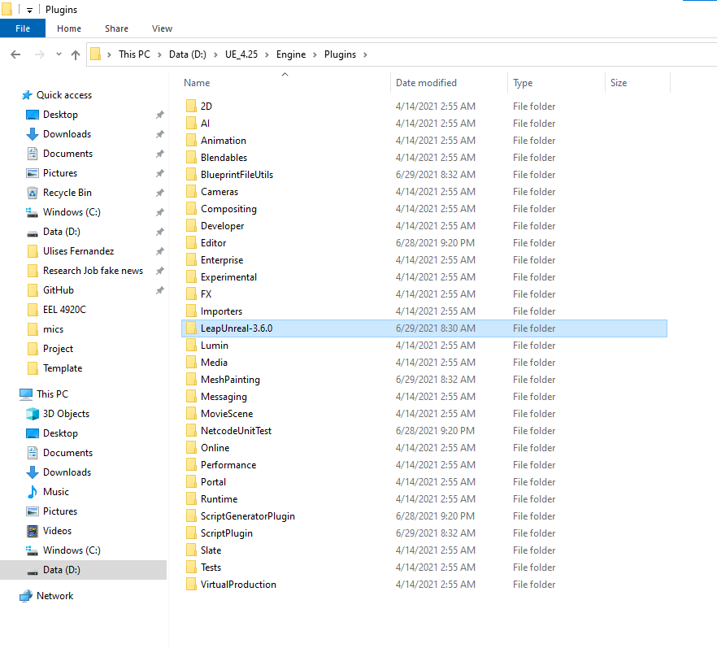

* 1. **Compiling Unreal Game Engine from Source** [**VIDEO**](https://www.youtube.com/watch?v=MRJUWC90aJM&ab_channel=Flopperam) 
     1. **Open your Terminal Application and go to the Unreal Engine folder**
     2. **Enter this command: Setup.bat**
     3. **Enter this command: GenerateProjectFiles.bat -2019**

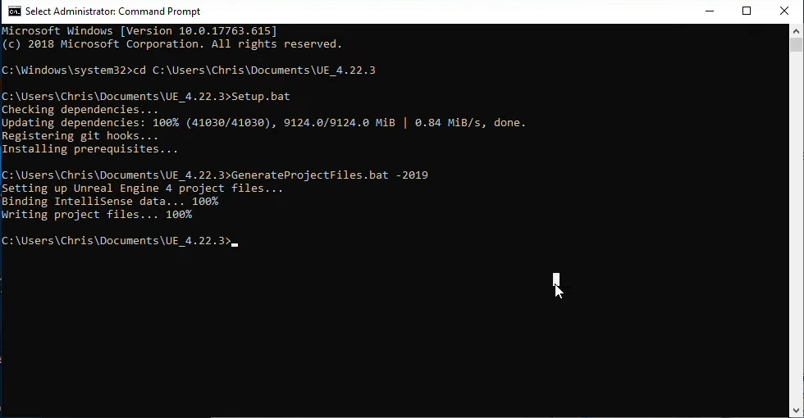

* + 1. **Open the UE4.sln file that was created**
    2. **Select Development Editor**
    3. **Select Win64**

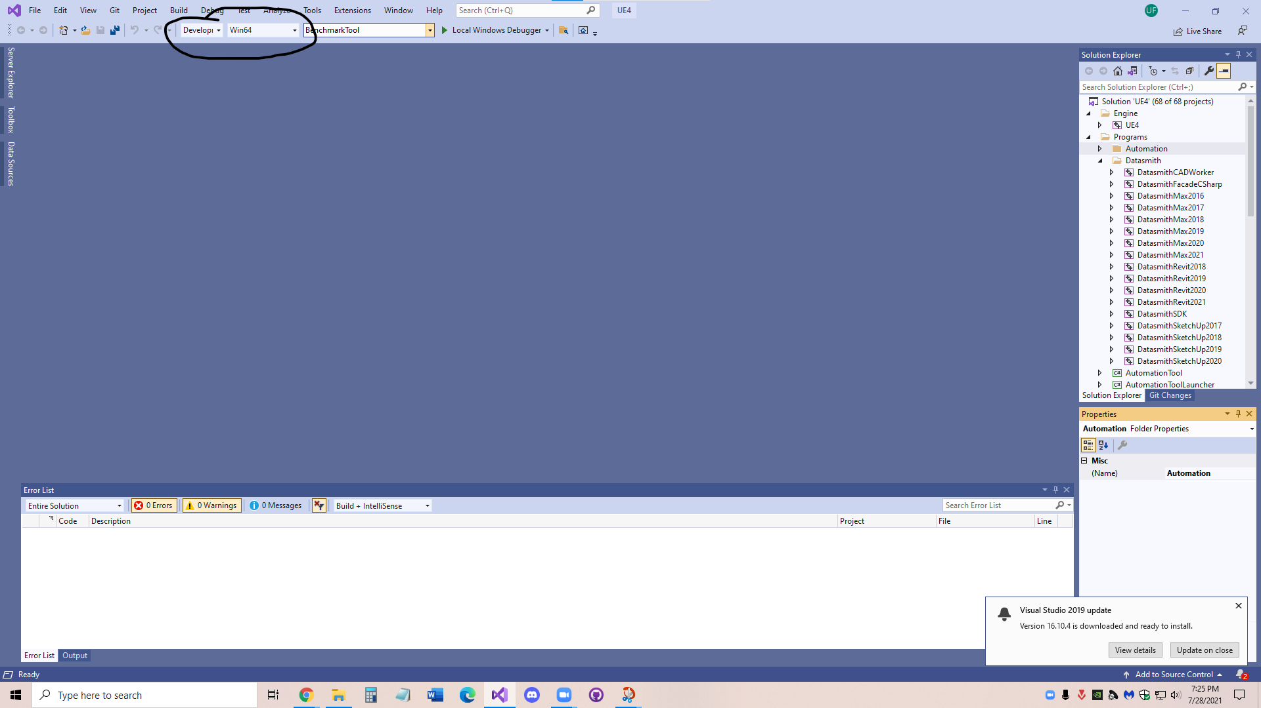

* + 1. **\*\*\*NOTE*** UE4 Compiling May take a day and File size may be around 70 to 100 GB.**
    2. **Right Click on UE4 and press Build**

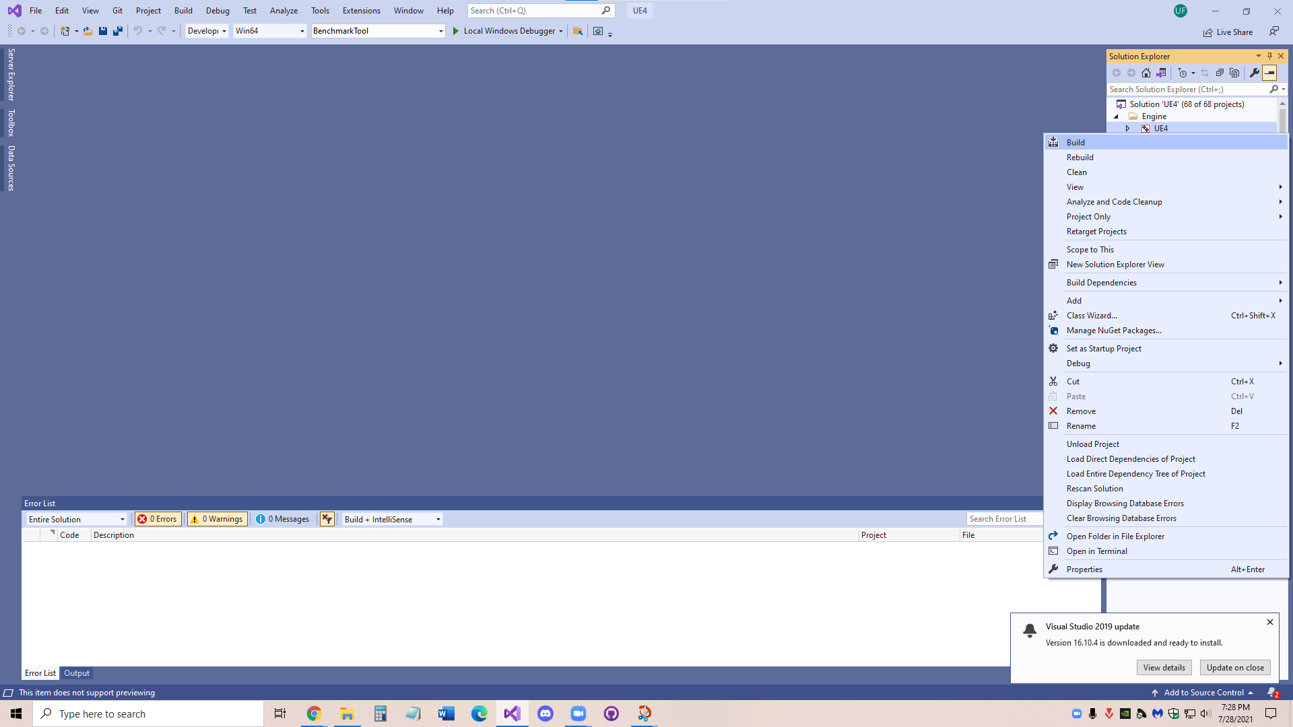

* + 1. **And you are DONE!**

1. **Opening The Project** 
   1. **Compiling Project against Unreal Engine** 
      1. **Unzip project code file**
      2. **Right Click on GamingGreaterGood_Team7.uproject**

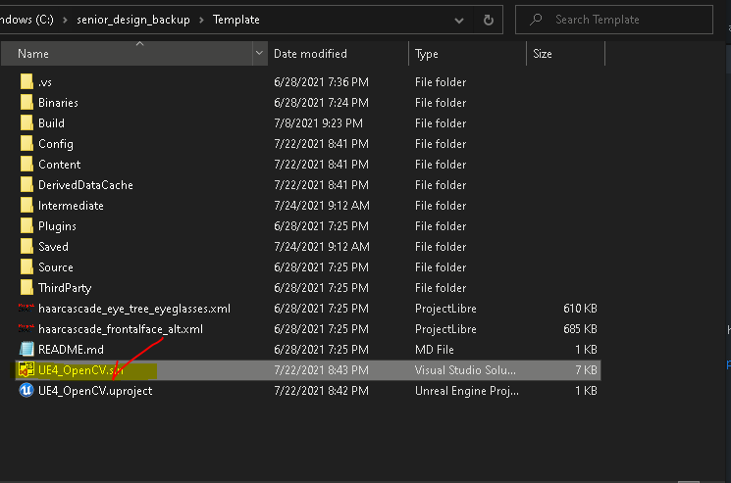

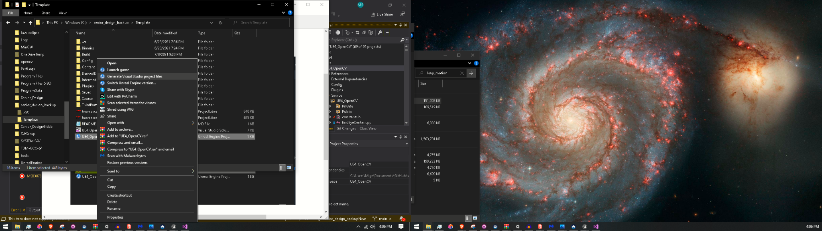

* + 1. **Click to switch Unreal Engine Version**
    2. **Select your engine version**
    3. **Right Click on GamingGreaterGood_Team7.uproject again**
    4. **Select generate Visual Studio Project Files**
    5. **Open GamingGreaterGood_Team7.sln file**
    6. **Right Click on the project name on the right side**

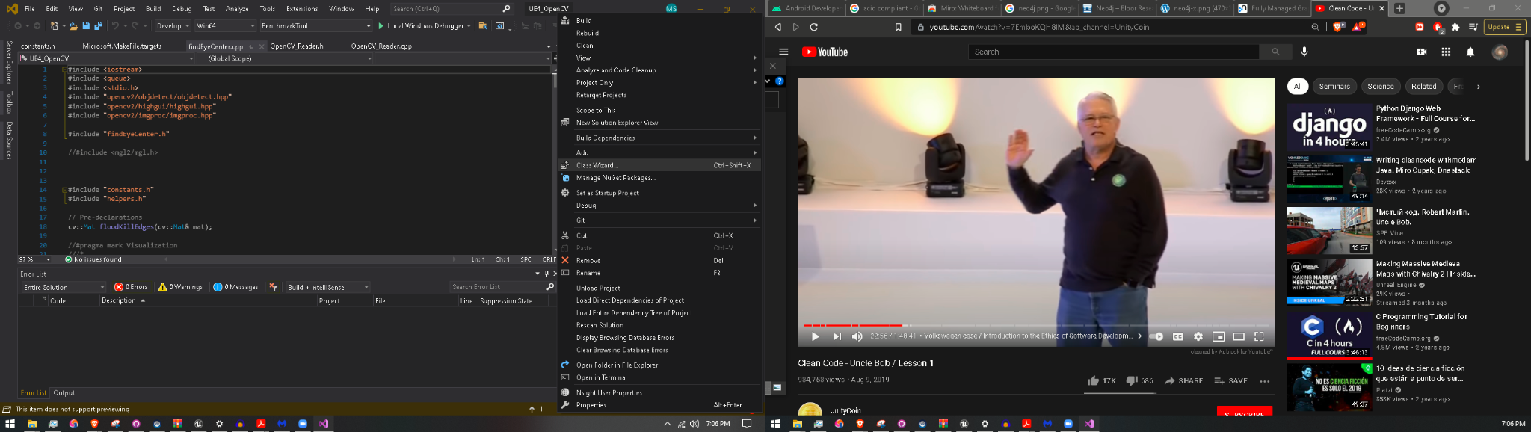

* + 1. **Click on Build**
    2. **Compile the project**

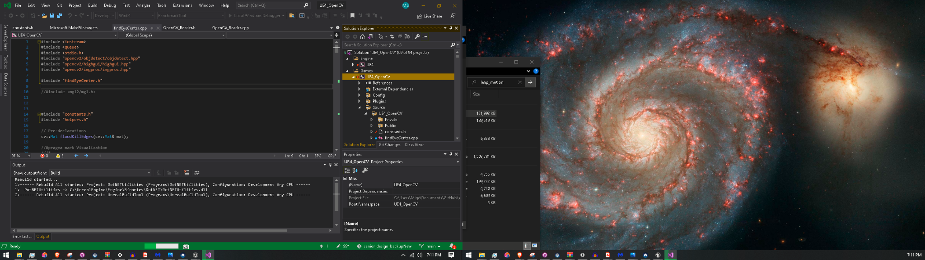

* + 1. **And you are DONE!**

1. **Running the Games**
   1. **Opening Leap Motion Control Panel**
      1. 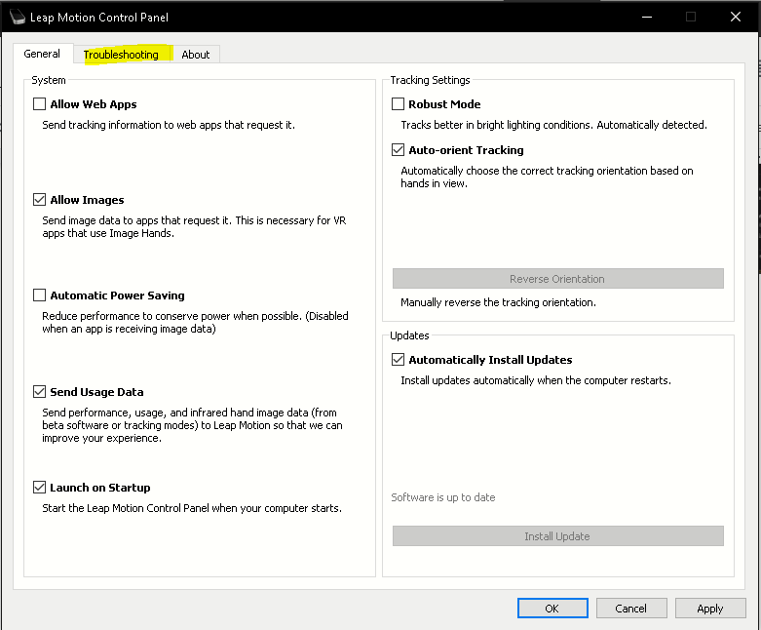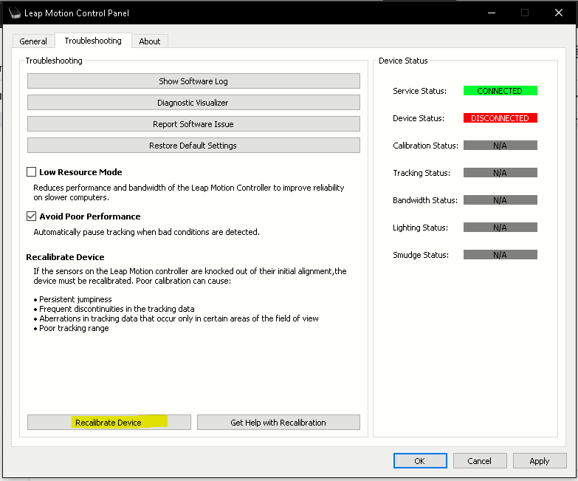
   2. **Configuring the Camera** 
      1. **Go to the Unreal Engine game editor**
      2. **Make sure the device is connected to the pc**
   3. **Opening Game**
      1. **Open the GamingGreaterGood_Team7.uproject**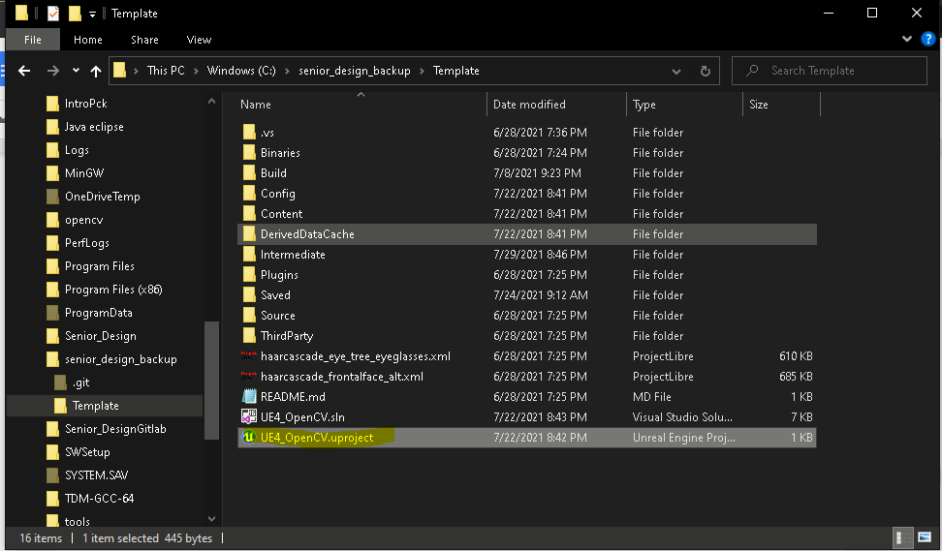
      2. 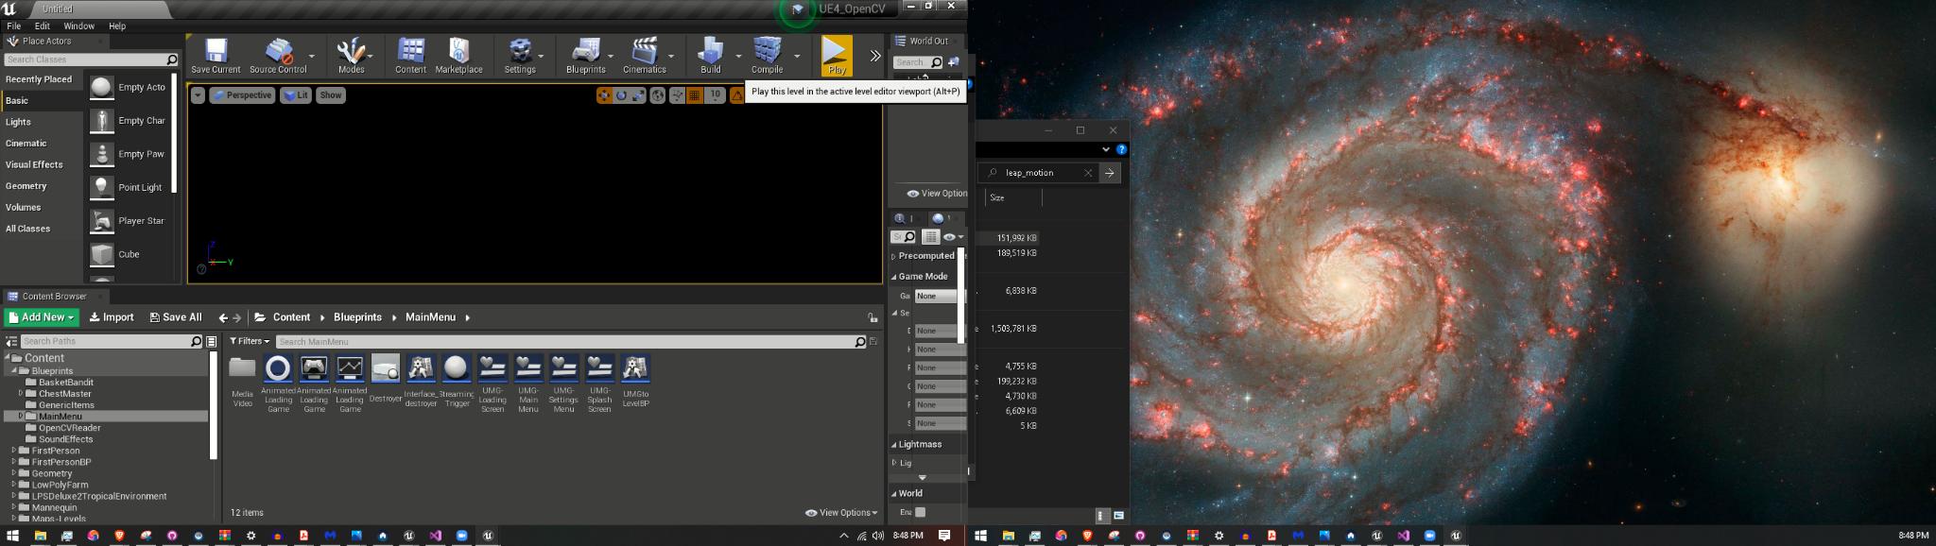

1. **Troubleshooting issues** 
   1. **Chest Master is crashing when trying to close the game**
      1. **Before closing Chest Master, inside the Content Browser under Blueprints go to the OpenCVReader folder and open the OpenCVMediaPlayer**

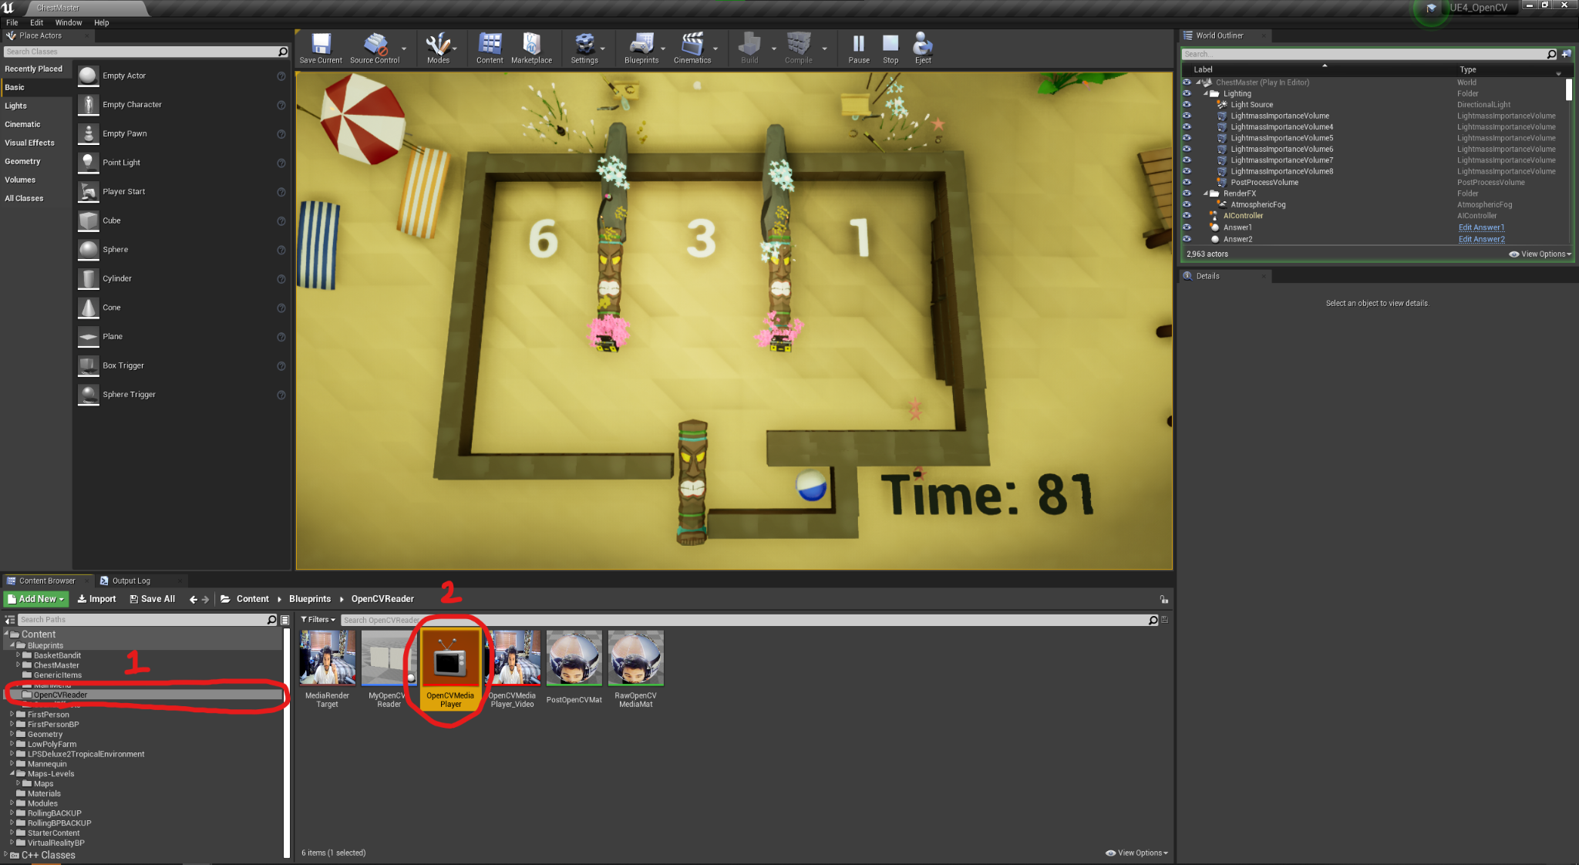

* + 1. **Pause the media, and close**

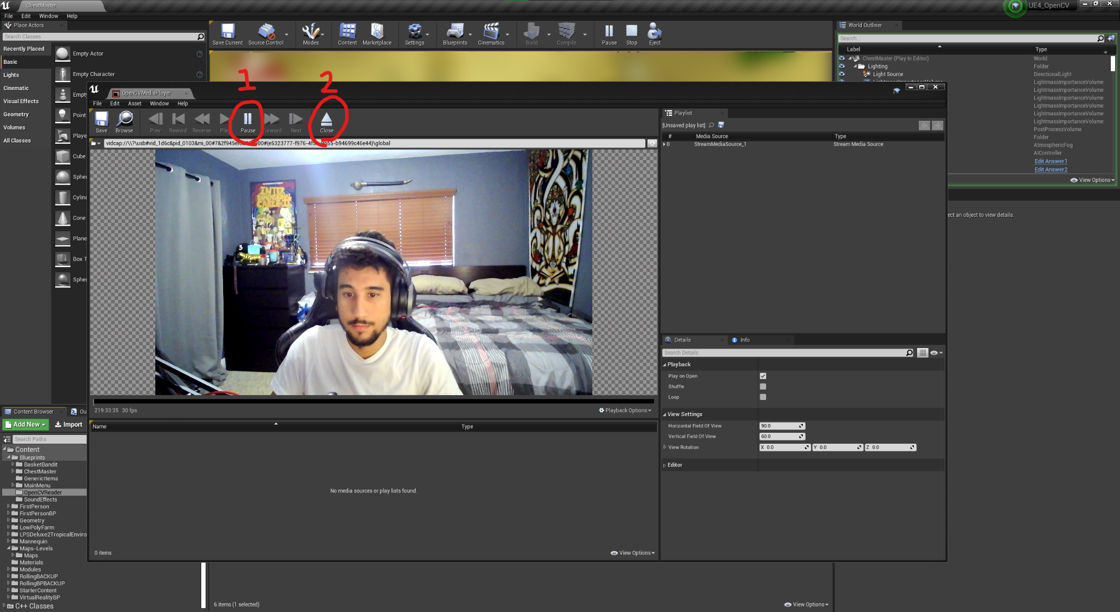

* + 1. **Pause the game, and close**

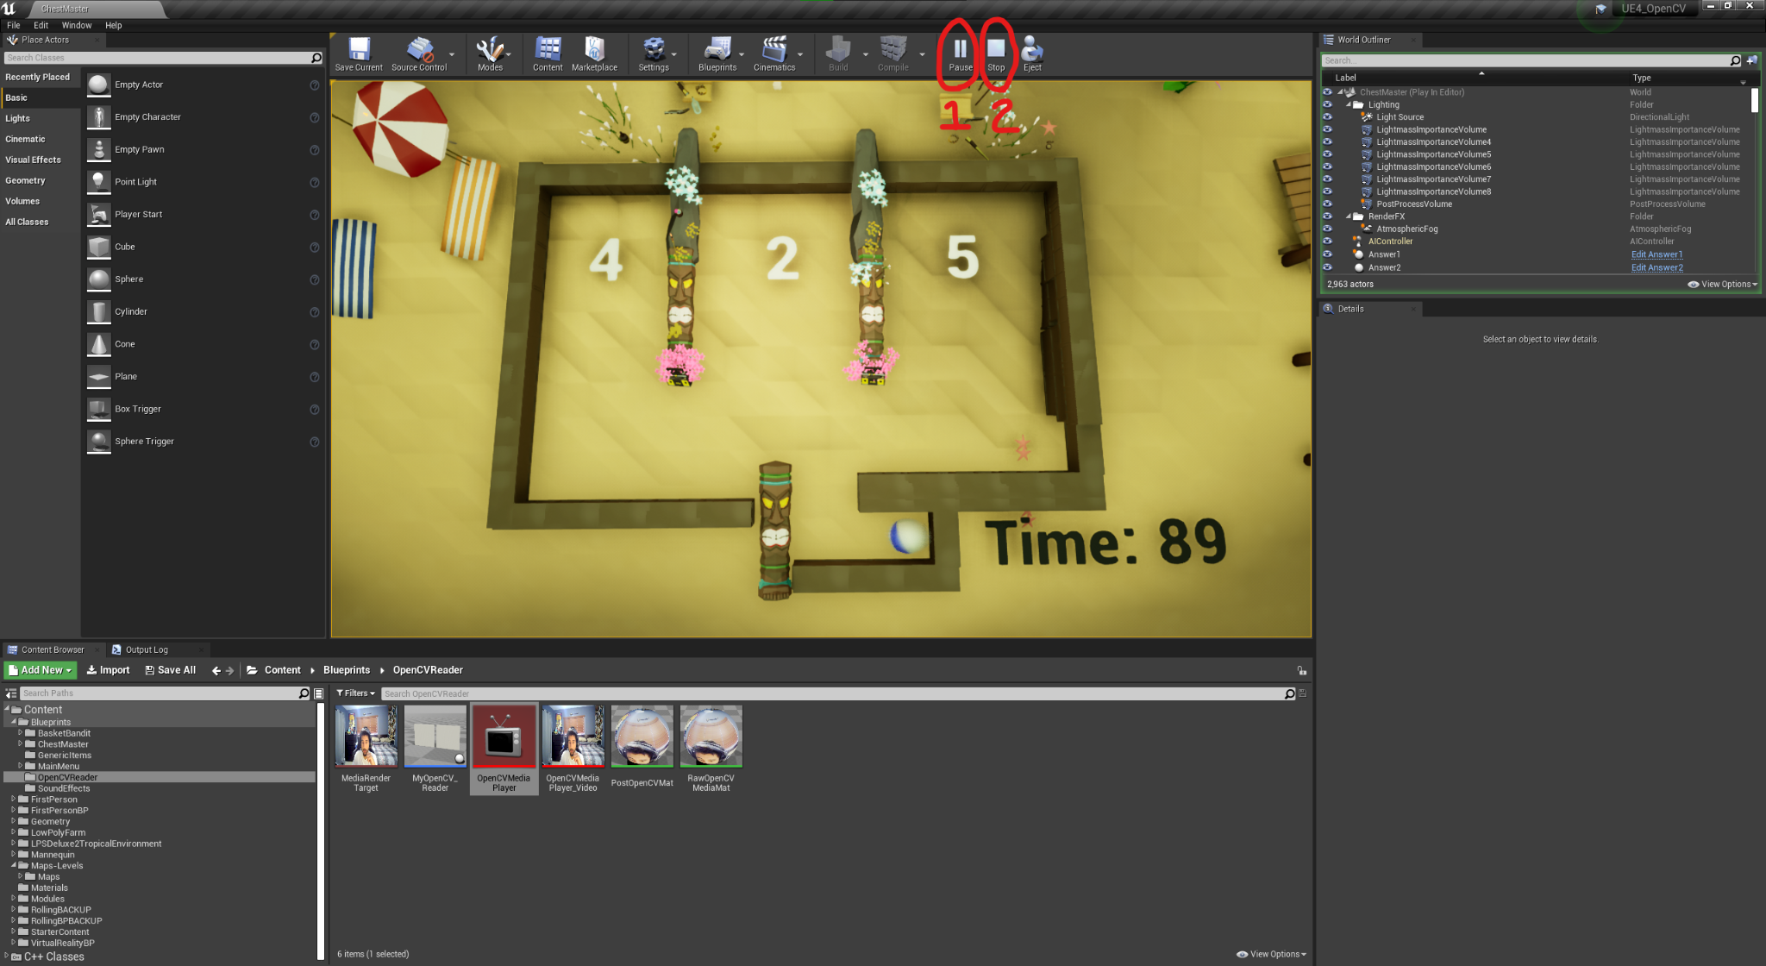

* 1. **The Camera is not working**
     1. **Unplug and replug**
     2. **Update your drivers**
     3. **Find the camera process and terminated it**
     4. **Setup camera with the OpenCVMediaPlayer**
        1. **Start Chest Master**
        2. **Inside the Content Browser under Blueprints go to the OpenCVReader folder and open the OpenCVMediaPlayer**



* + - 1. **Click the small folder on the top left, hover over the video category, then click your desired camera**

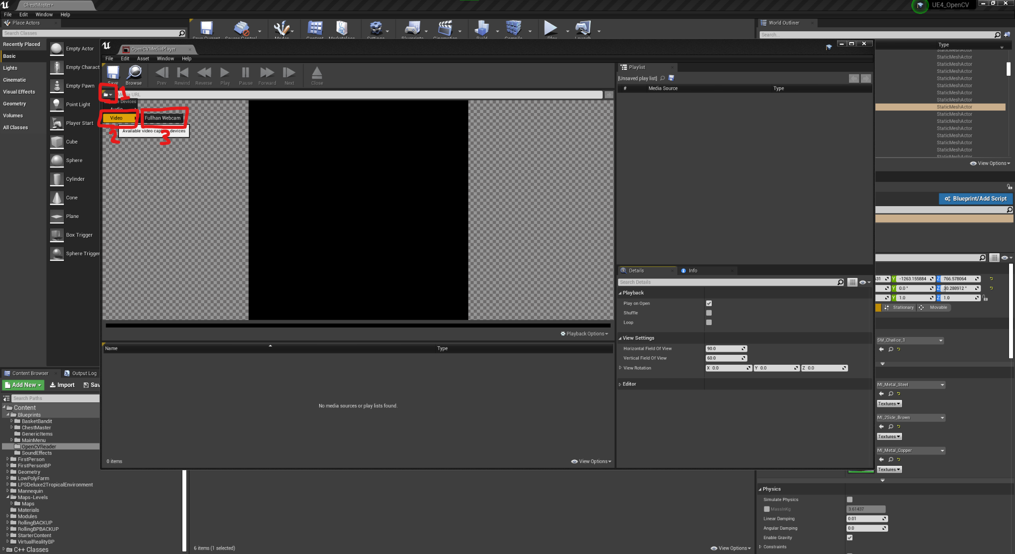

* + - 1. **(optional) if no image is showing, click “playback options” on the bottom right, hover over video, then select the appropriate track. Then, press play.**

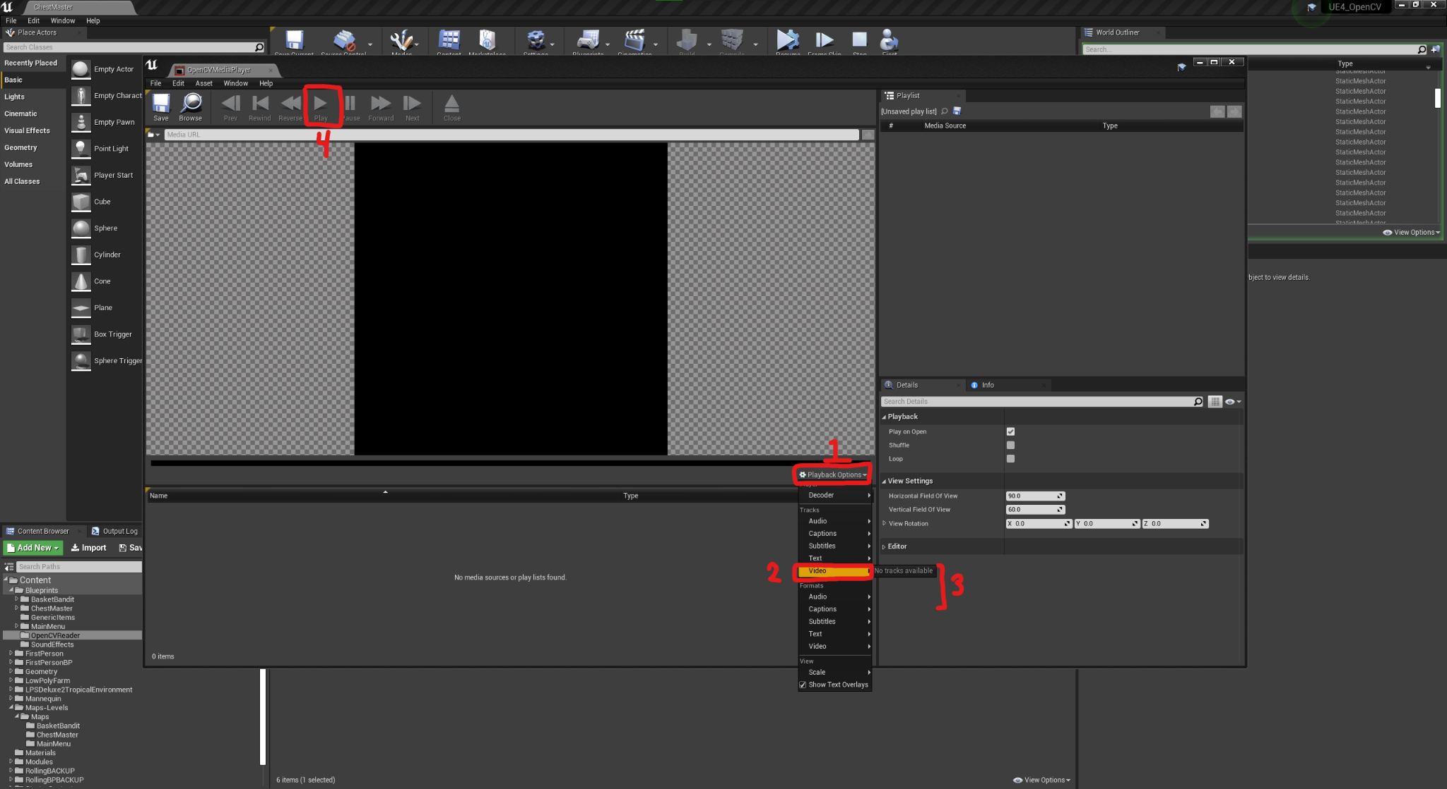

* 1. **The Leap Motion Control is not tracking my hands**
     1. **Unplug and replug**
     2. **Update your drivers**
     3. **Clean the lens**
  2. **My project is not opening**
     1. **Rebuild project from Visual Studio**
        1. **Open the GamingGreaterGood_Team7.sln file**
        2. **On the right, under the solution explorer inside the games folder, right click the project name and click rebuild (WARNING: this can take a few of hours and will max out your CPU)**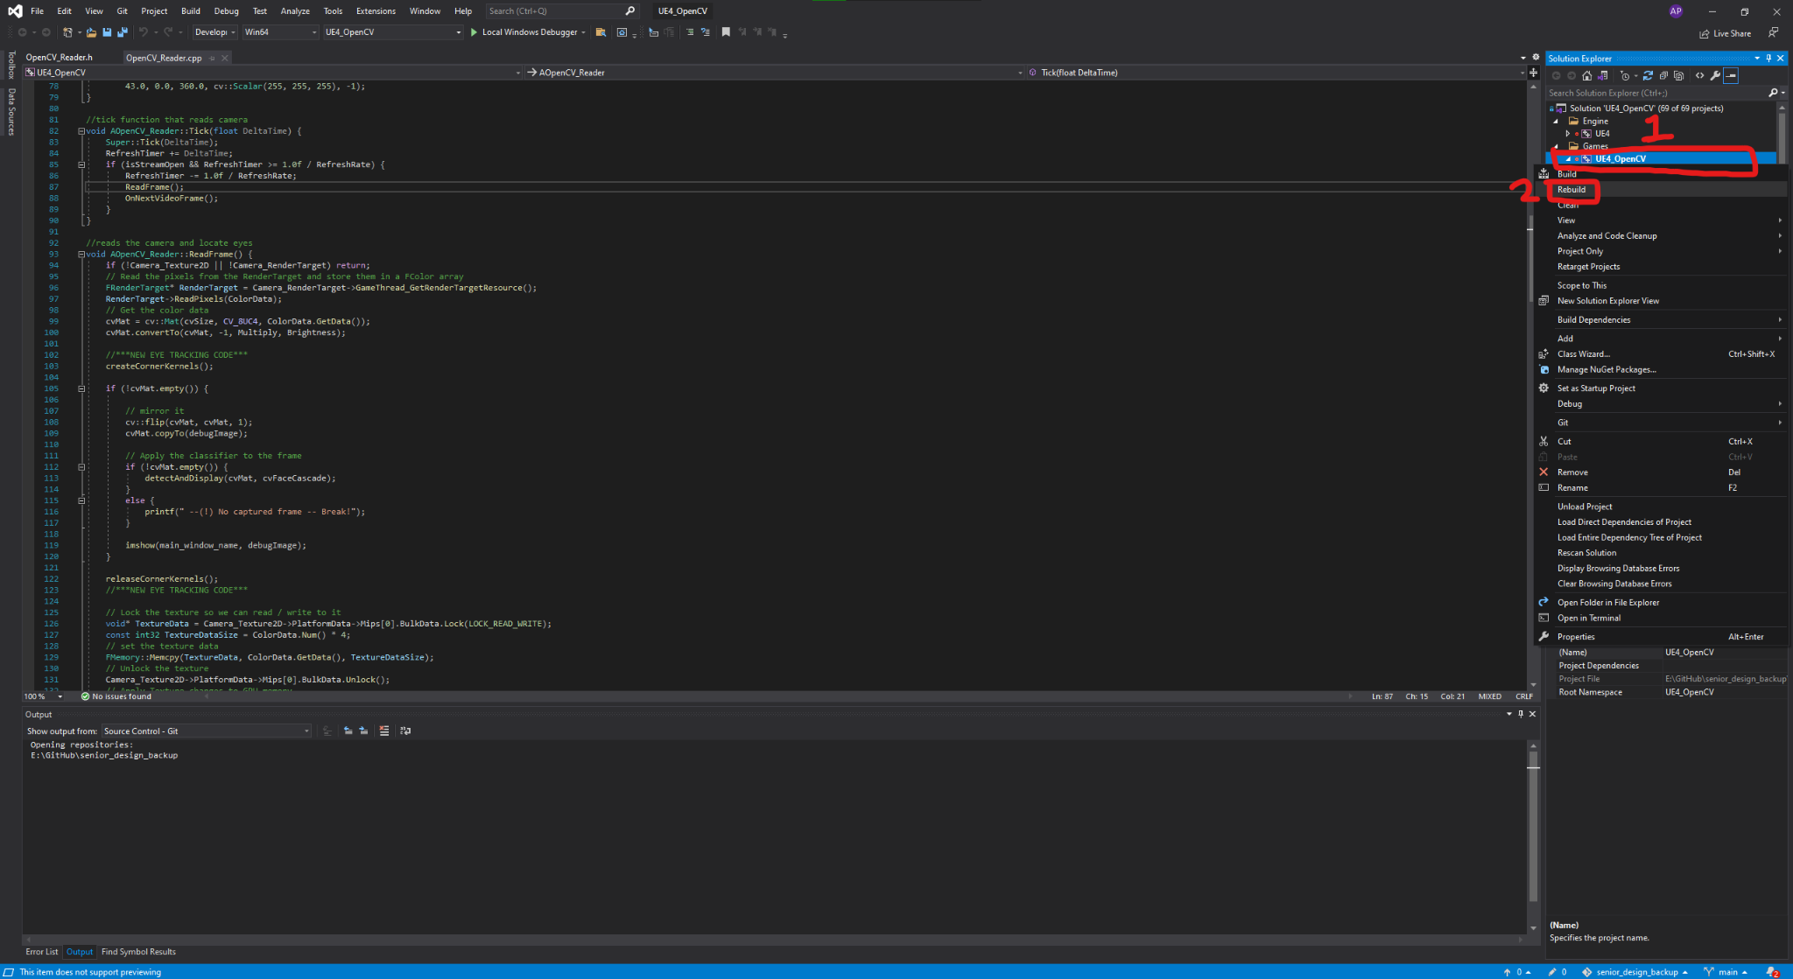
        3. **Reopen the project**
     2. **Re-clone the project**
        1. **(optional) if you are asked to build after opening the project, click yes. This should take less than a minute. If it fails, you’ll need to build the project from Visual Studio.**

**Thank you for downloading our project!**



**TEAM 7**